- Given two Binary Trees, write a function that returns true if two trees are mirror of each other, else false. For example, the function should return true for following input trees.

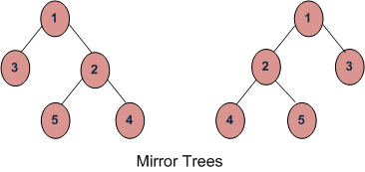

Solution:
Node a, b;
/* Given two trees, return true if they are
mirror of each other */
boolean areMirror(Node a, Node b)
{
/* Base case : Both empty */
if (a == null && b == null)
return true;

// If only one is empty
if (a == null || b == null)
return false;

/* Both non-empty, compare them recursively
Note that in recursive calls, we pass left
of one tree and right of other tree */
return a.data == b.data
&& areMirror(a.left, b.right)
&& areMirror(a.right, b.left);
}//function closed
- Given a binary tree and an array, the task is to find if the given array sequence is present as a root-to-leaf path in given tree.
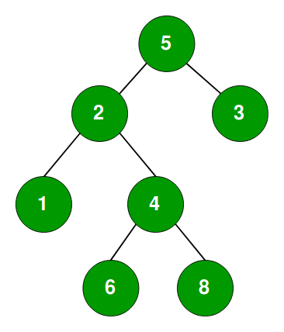

Input : arr[] = {5, 2, 4, 8} for above tree
Output: "Path Exist"
Input : arr[] = {5, 3, 4, 9} for above tree
Output: "Path does not Exist"

Solution:
// Util function
public boolean existPathUtil(Node root, int arr[],
int n, int index)
{
// If root is NULL or
// reached end of the array
if(root == null || index==n)
return false;

// If current node is leaf
if (root.left == null &&
root.right == null)
{
if((root.data == arr[index]) &&
(index == n-1))
return true;

return false;
}

// If current node is equal to arr[index] this means
// that till this level path has been matched and
// remaining path can be either in left subtree or
// right subtree.
return ((index < n) && (root.data == arr[index])
&& (existPathUtil(root.left, arr, n, index+1)
|| existPathUtil(root.right, arr, n, index+1) ));
}

// Function to check given sequence of root
// to leaf path exist in tree or not.
// index : current element in sequence of root to
// leaf path
public boolean existPath(Node root, int arr[],
int n, int index)
{
if(root == null)
return (n==0);

return existPathUtil(root, arr, n, 0);
}

- Given a binary tree, where every node value is a Digit from 1-9. Find the sum of all the numbers which are formed from root to leaf paths.

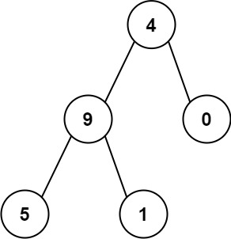

Output: 1026
Explanation:
The root-to-leaf path 4->9->5 represents the number 495.
The root-to-leaf path 4->9->1 represents the number 491.
The root-to-leaf path 4->0 represents the number 40.
Therefore, sum = 495 + 491 + 40 = 1026.

Solution:
Node root;

// Returns sum of all root to leaf paths. The first parameter is
// root of current subtree, the second parameter is value of the
// number formed by nodes from root to this node
int treePathsSumUtil(Node node, int val)
{
// Base case
if (node == null)
return 0;

// Update val
val = (val * 10 + node.data);

// if current node is leaf, return the current value of val
if (node.left == null && node.right == null)
return val;

int l = treePathsSumUtil(node.left, val);
int r = treePathsSumUtil(node.right, val);

return l+r;

}// function closed

// A wrapper function over treePathsSumUtil()
int treePathsSum(Node node)
{
// Pass the initial value as 0 as there is nothing above root
return treePathsSumUtil(node, 0);

}//function closed

- Given the root of a binary tree, return the sum of values of nodes with an even-valued grandparent. If there are no nodes with an even-valued grandparent, return 0.
A grandparent of a node is the parent of its parent if it exists.

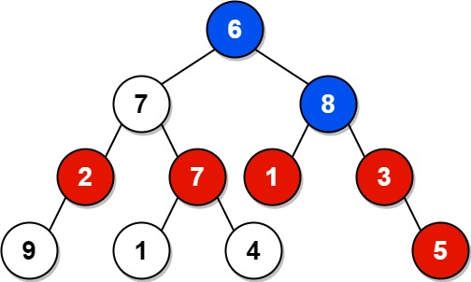

Input: root = [6,7,8,2,7,1,3,9,null,1,4,null,null,null,5]
Output: 18
Explanation: The red nodes are the nodes with even-value grandparent while the blue nodes are the even-value grandparents.

Solution:

int sum=0;

void helper(TreeNode root)
{
if(!root)return;

if(root.val%2==0)
{
if(root.left)
{
if(root.left.left)
sum+=root.left.left.val;

if(root.left.right)
sum+=root.left.right.val;

}

if(root.right)
{
if(root.right.left)
sum+=root.right.left.val;

if(root.right.right)
sum+=root.right.right.val;

}
}//if closed

helper(root.left);
helper(root.right);

}

int sumEvenGrandparent(TreeNode root) {

if(!root)
return 0;
helper(root);
return sum;

}//function closed

- Given the root of a binary tree, return the sum of values of its deepest leaves.
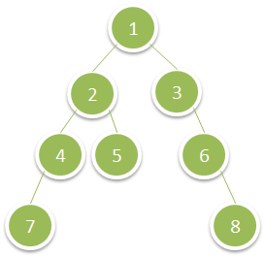

Input: root = [1,2,3,4,5,null,6,7,null,null,null,null,8]
Output: 15

Solution:

int maxi=0;
int ht(TreeNode* root)
{
if(!root)
return 0;

return 1+(max(ht(root.left),ht(root.right)));

}//function closed

void sumf(TreeNode root,int l,int h)
{
if(!root)return;

if(root.left==NULL && root.right == NULL)
{

if(l==h)
maxi=maxi+root.val;
}
sumf(root->left,l+1,h);
sumf(root->right,l+1,h);

}//function closed

int deepestLeavesSum(TreeNode root) {
if(!root)
return 0;

int h=ht(root);

sumf(root,0,h-1);
return maxi;

}

